

BAN 610: Database Management & Application

Fall, 2022 Group Project

**Group - 5**

Team Members

1. Akhil Mohan - to6616
2. Megh Dave - cc3118
3. Sam Thomas - my4704
4. Varshini Kuppuraj - wd1464
5. Julian Antoine Honrado - hv1231
6. **Introduction**

Due to the new environmental regulations in the State of California, all the residential communities in California have to implement an IoT metering system to track usage. VJAMS is an IoT metering company which provides meters for energy, water, gas, etc. to house owners. They have been asked by the communities to set it up. These meters provide readings on usage for these utilities. VJAMS has done a preliminary analysis and come up with the following set of entities, attributes, and business rules:

1. **User Requirements/ Business Rules**
2. **Community**

A community has several houses. There can be multiple residents in a house and a resident can also have many houses. The community is identified by its ID. Its other attributes are name, address, and contact person/s.

1. **Resident**

Each resident is identified by their user ID. Each resident also has a name, household number/s and access type (admin and user). A resident can be both an admin and a user. Some users could also be admins but most of the residents are users.

1. **House**

A house can be identified by its house number. Another attribute of the house would also be the number of meters it holds. A house can have multiple meters.

1. **Bill**

A bill is assigned by the community to each house by multiplying the rate per unit with monthly usage. Each house then pays for the bill. The bill is identified by its bill number.

1. **Meter and Reading**

A meter has a unique ID and multiple readings. The readings contain the time and date stamp.

The readings can be accessed by each house. The readings provide the monthly and daily usage along with the monthly and daily average. The readings also provide error reports which are generated by the admin whenever there are any changes made to the meter (i.e wrong readings, network down, broken pipes, etc.). Each report has a unique ID and shows the issues, the readings before and after with a time and date stamp and the changes made to the meter.

1. **Conceptual Data Modeling/ERD Diagram**

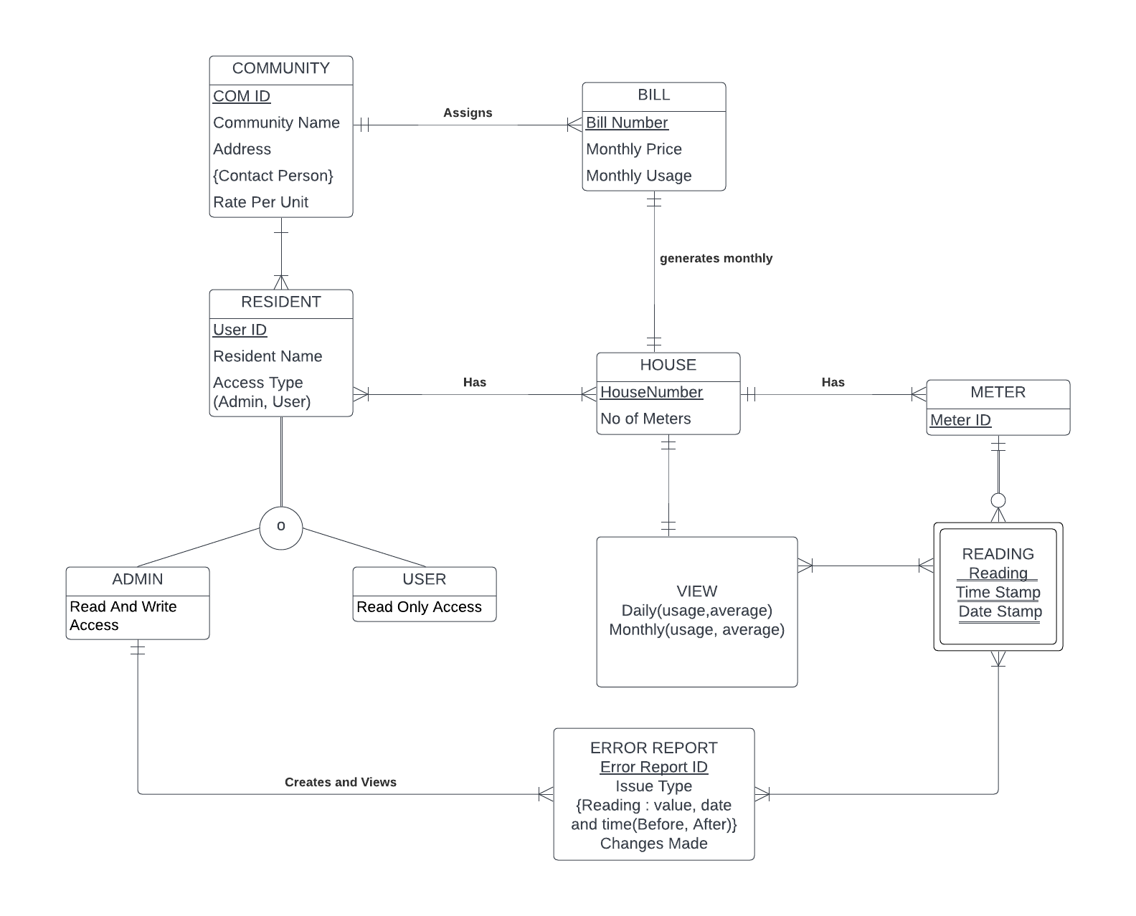

**IV. Logical Database Design**

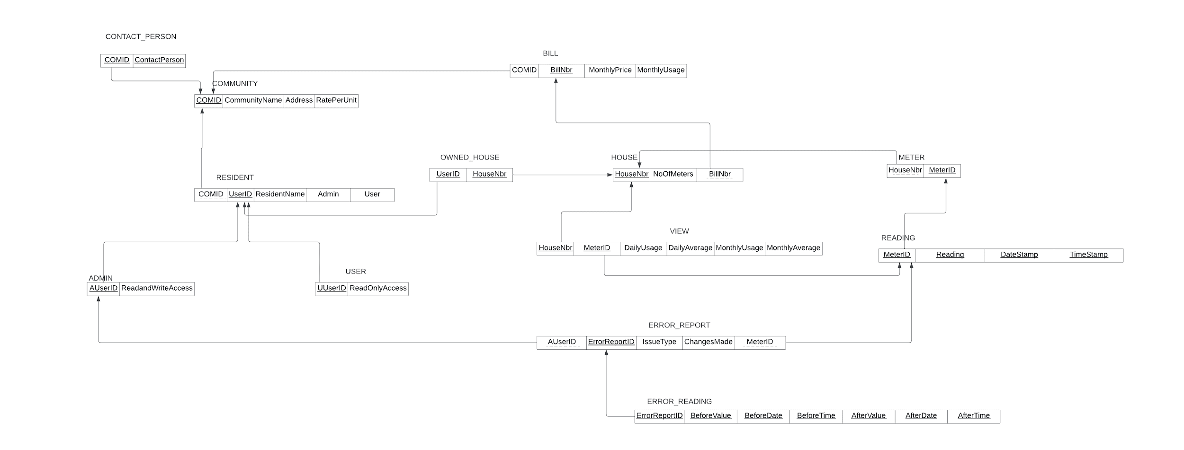

**V. Metadata**

CONTACT_PERSON

|  |  |  |  |  |  |
| --- | --- | --- | --- | --- | --- |
| Attribute | Data Type | Size | AUTO | Null | Constraint |
| COMID | Int | 11 | No | No | Part Primary, Foreign |
| ContactPerson | Varchar | 50 | No | No | Part Primary |

COMMUNITY

|  |  |  |  |  |  |
| --- | --- | --- | --- | --- | --- |
| Attribute | Data Type | Size | AUTO | Null | Constraint |
| COMID | Int | 11 | Yes | No | Primary |
| CommunityName | Varchar | 50 | No | No |  |
| Address | Varchar | 50 | No | No |  |
| RatePerUnit | double |  | No | No |  |

RESIDENT

|  |  |  |  |  |  |
| --- | --- | --- | --- | --- | --- |
| Attribute | Data Type | Size | AUTO | Null | Constraint |
| UserID | Int | 11 | Yes | No | Primary |
| ResidentName | Varchar | 50 | No | No |  |
| Admin | Varchar | 3 | No | No |  |
| User | Varchar | 3 | No | No |  |
| COMID | Int | 11 |  |  | Foreign |

ADMIN

|  |  |  |  |  |  |
| --- | --- | --- | --- | --- | --- |
| Attribute | Data Type | Size | AUTO | Null | Constraint |
| AUserID | Int | 11 | No | No | Primary, foreign |
| ReadandWriteAccess | Varchar | 3 | No | No |  |

USER

|  |  |  |  |  |  |
| --- | --- | --- | --- | --- | --- |
| Attribute | Data Type | Size | AUTO | Null | Constraint |
| UUserID | Int | 11 | No | No | Primary, foreign |
| ReadOnlyAccess | Varchar | 3 | No | No |  |

OWNED_HOUSE

|  |  |  |  |  |  |
| --- | --- | --- | --- | --- | --- |
| Attribute | Data Type | Size | AUTO | Null | Constraint |
| UserID | Int | 11 | No | No | Part of Primary,foreign |
| HouseNbr | Varchar | 3 | No | No | Part of Primary,foreign |

BILL

|  |  |  |  |  |  |
| --- | --- | --- | --- | --- | --- |
| Attribute | Data Type | Size | AUTO | Null | Constraint |
| BillNbr | Int | 11 | Yes | No | Primary |
| Monthly Price | Double |  | No | No |  |
| Monthly Usage | Int | 11 | No | No |  |
| COMID | Int | 11 | No | No | foreign |

HOUSE

|  |  |  |  |  |  |
| --- | --- | --- | --- | --- | --- |
| Attribute | Data Type | Size | AUTO | Null | Constraint |
| HouseNbr | Int | 11 | Yes | No | Primary |
| NoOfMeters | Int | 11 | No | No |  |
| BillNbr | Int | 11 | No | Yes | foreign |

METER

|  |  |  |  |  |  |
| --- | --- | --- | --- | --- | --- |
| Attribute | Data Type | Size | AUTO | Null | Constraint |
| MeterID | Int | 11 | Yes | No | Primary |
| HouseNbr | Int | 11 | No | Yes | foreign |

READING

|  |  |  |  |  |  |
| --- | --- | --- | --- | --- | --- |
| Attribute | Data Type | Size | AUTO | Null | Constraint |
| MeterID | Int | 11 | No | No | Part of primary, foreign |
| Reading | Int | 11 | No | No | Part of primary |
| DateStamp | Date |  | No | No | Part of primary |
| TimeStamp | Time |  | No | No | Part of primary |

VIEW

|  |  |  |  |  |  |
| --- | --- | --- | --- | --- | --- |
| Attribute | Data Type | Size | AUTO | Null | Constraint |
| HouseNbr | Int | 11 | No | No | Part of primary, foreign |
| MeterID | Int | 11 | No | No | Part of primary, foreign |
| DailyUsage | Varchar | 20 | No | No |  |
| DailyAverage | Varchar | 20 | No | No |  |
| MonthlyUsage | Varchar | 20 | No | No |  |
| MonthlyAverage | Varchar | 20 | No | No |  |

ERROR REPORT

|  |  |  |  |  |  |
| --- | --- | --- | --- | --- | --- |
| Attribute | Data Type | Size | AUTO | Null | Constraint |
| ErrorReportID | Int | 11 | Yes | No | Primary |
| IssueType | Varchar | 20 | No | No |  |
| ChangesMade | Varchar | 50 | No | No |  |
| AUserID | Int | 11 | No | Yes | foreign |
| MeterID | Int | 11 | No | Yes | foreign |

ERROR READING

|  |  |  |  |  |  |
| --- | --- | --- | --- | --- | --- |
| Attribute | Data Type | Size | AUTO | Null | Constraint |
| ErrorReportID | Int | 11 | Yes | No | Part of Primary, foreign |
| BeforeValue | Varchar | 30 | No | No | Part of Primary |
| BeforeDate | Date |  | No | No | Part of Primary |
| BeforeTime | Time |  | No | No | Part of Primary |
| AfterValue | Varchar | 30 | No | No | Part of Primary |
| AfterDate | Date |  | No | No | Part of Primary |
| AfterTime | Time |  | No | No | Part of Primary |

**VI. SQL Implementation**

**A. Schema**

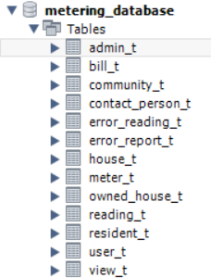

**B. Tables**

**Community Table**

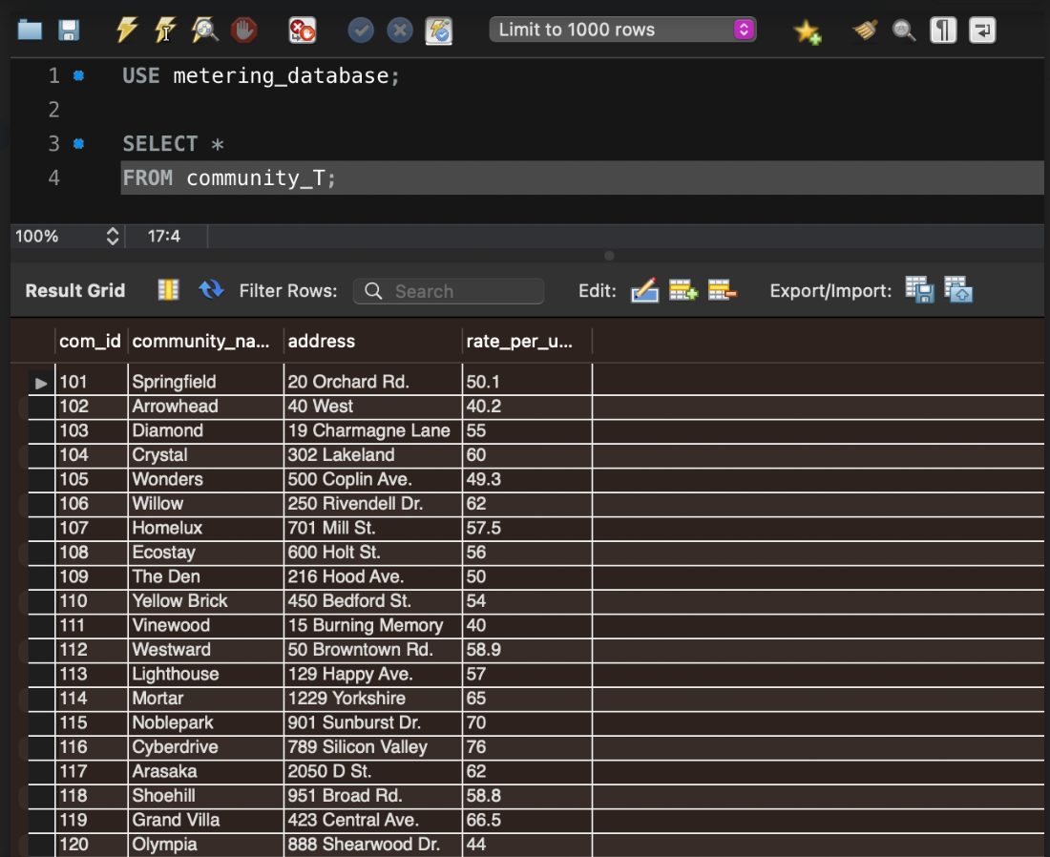

**Contact Person Table**

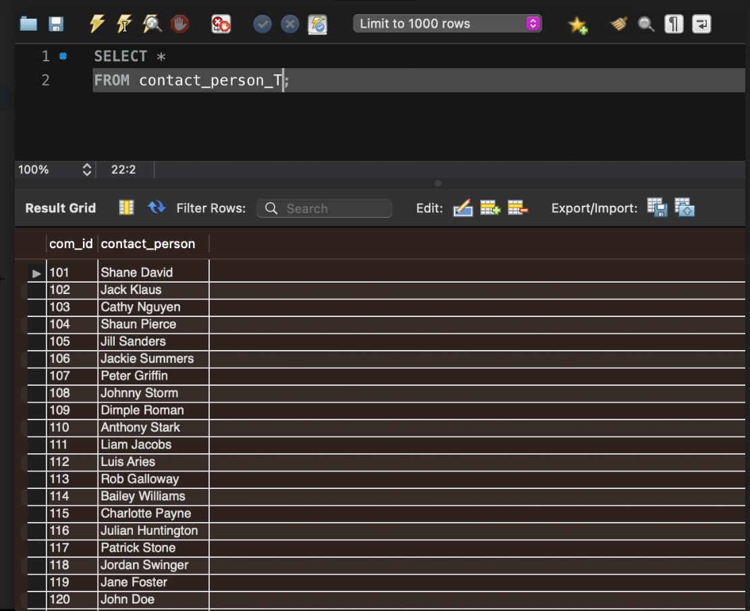

**Resident Table**

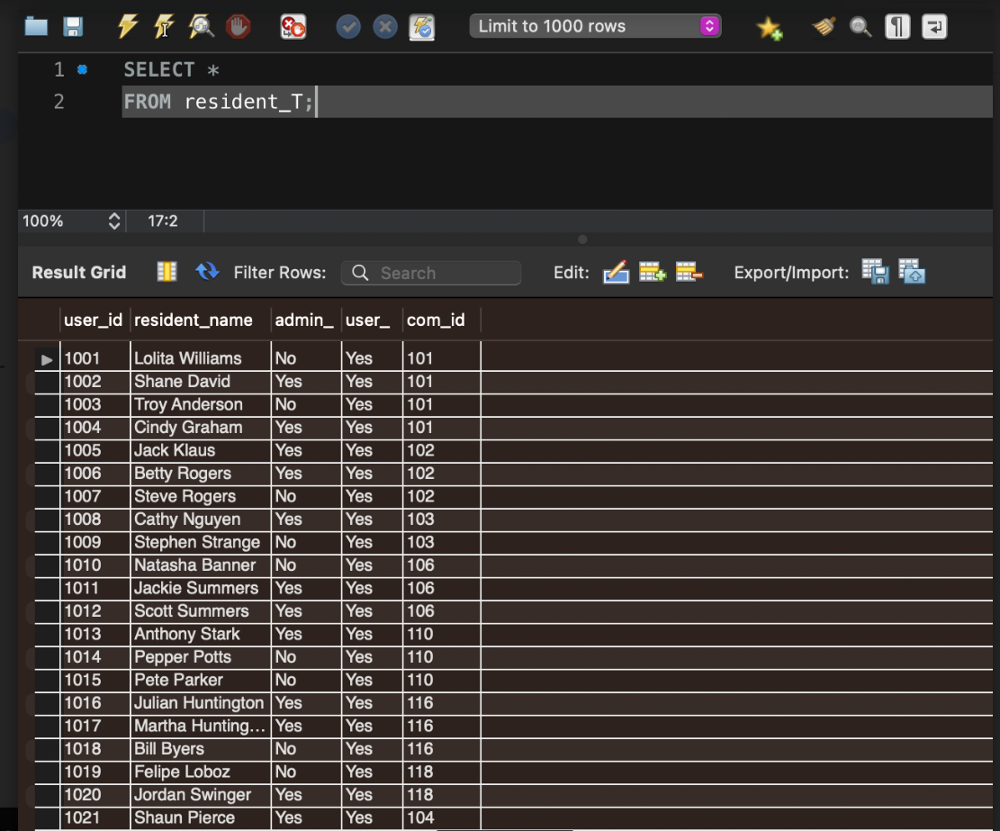

**Admin Table**

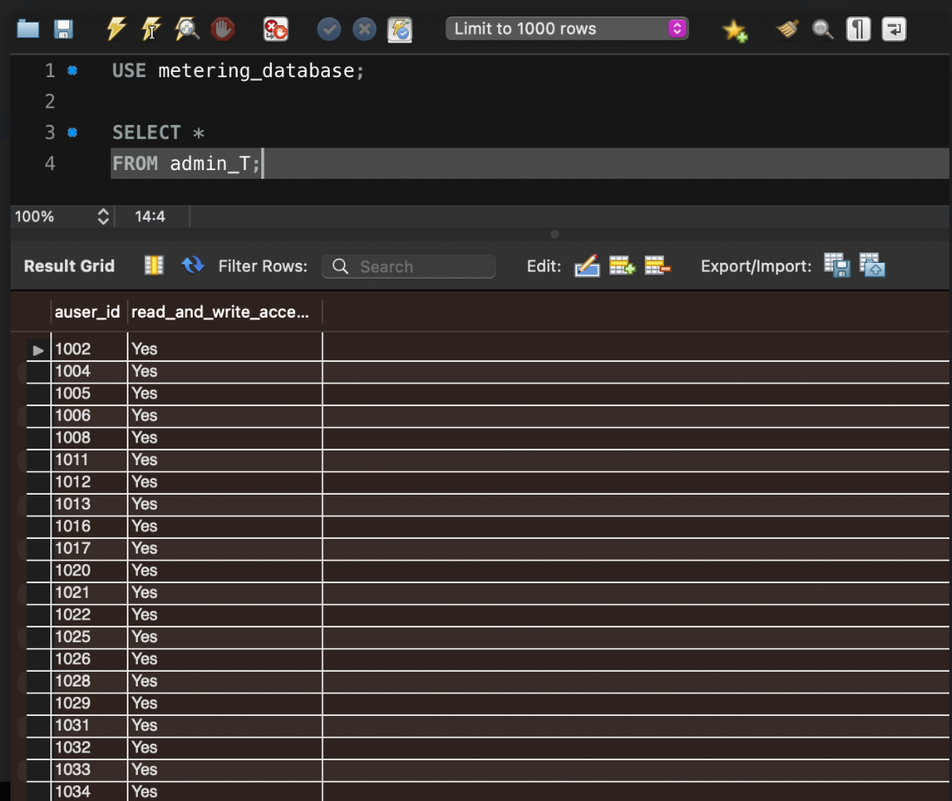

**User Table**

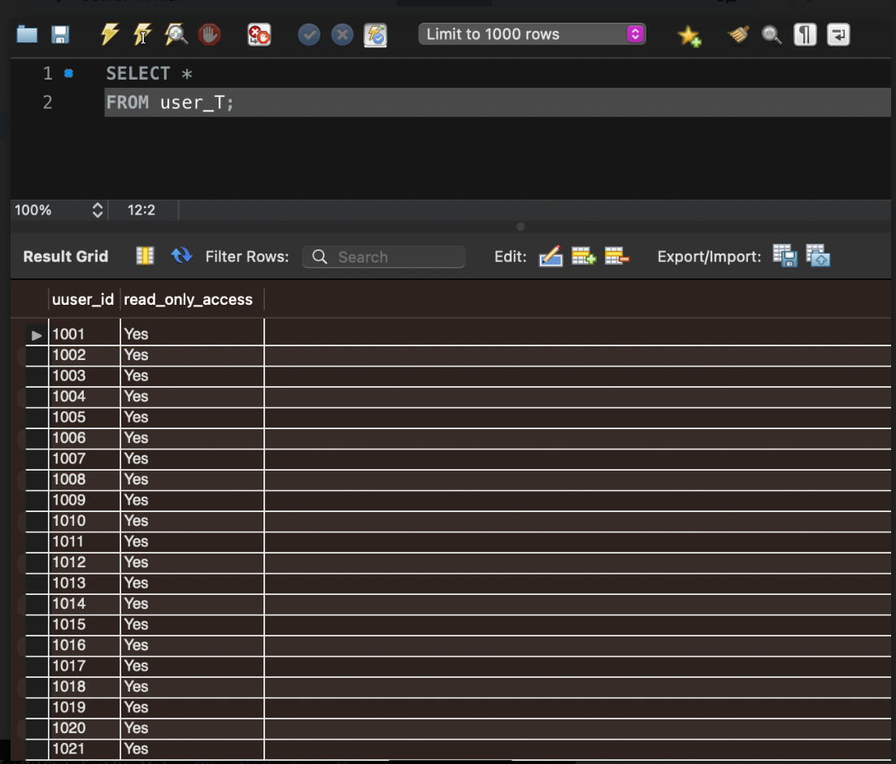

**Bill Table**

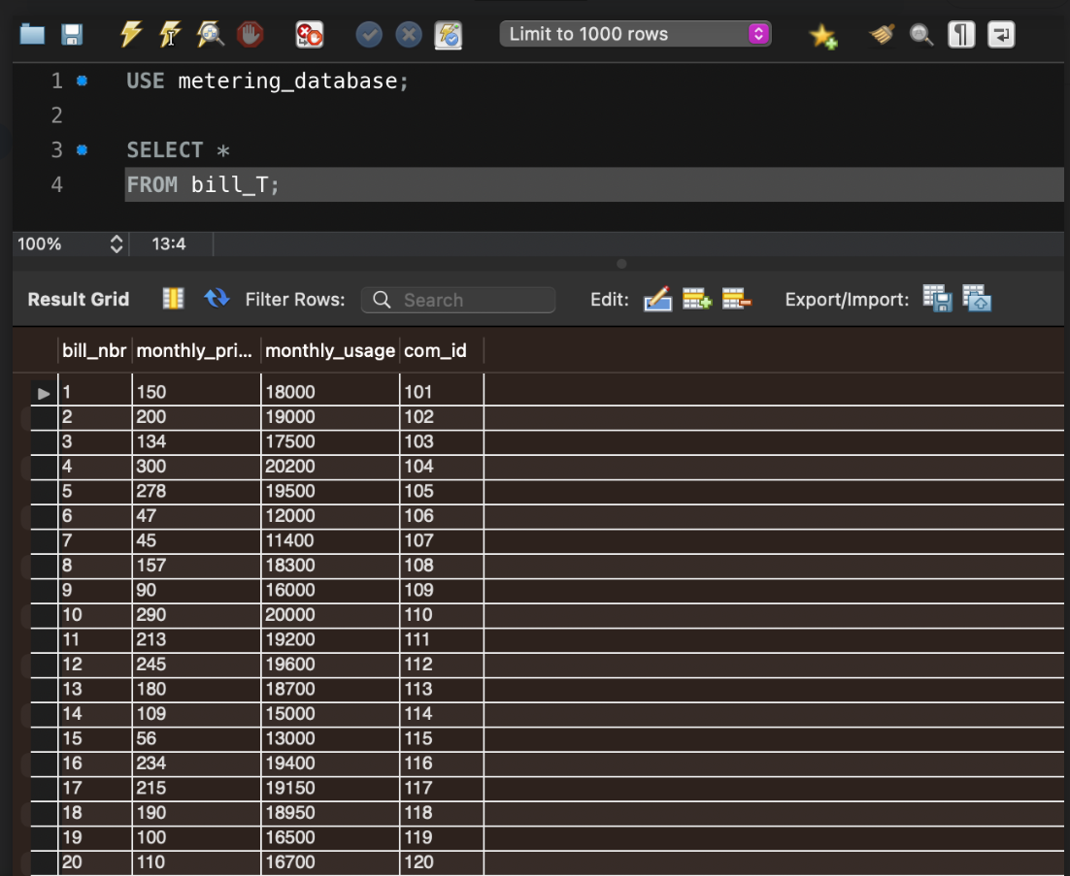

**House Table**

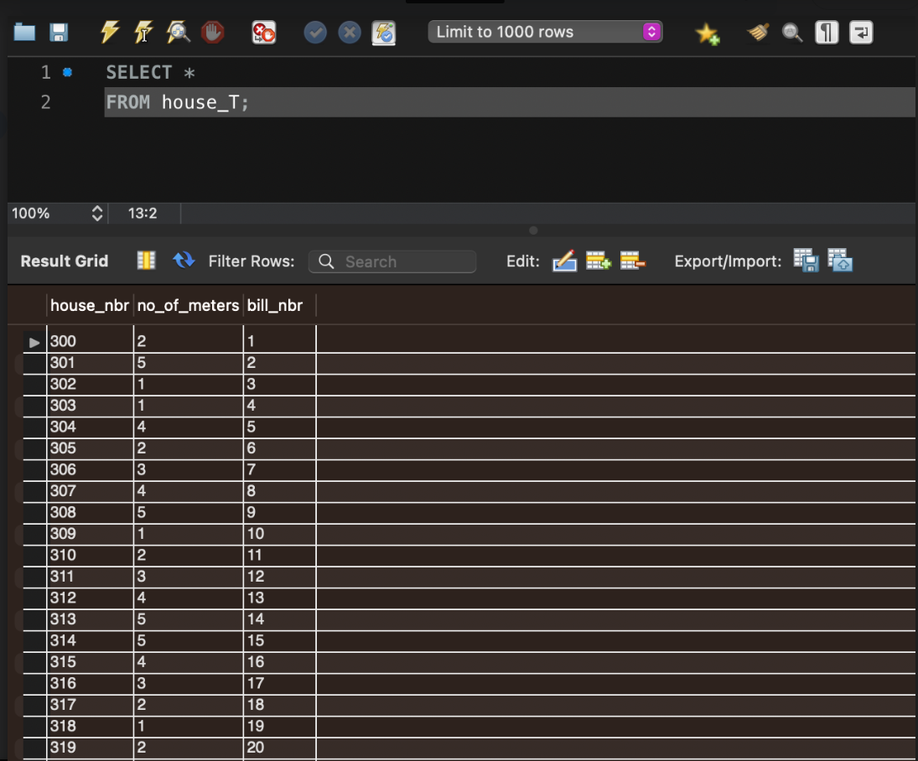

**Owned House Table**

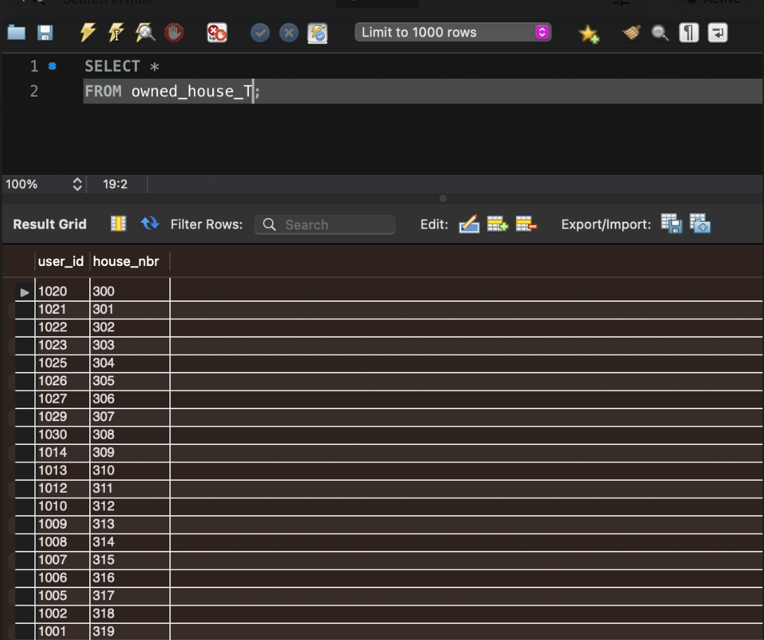

**Meter Table**

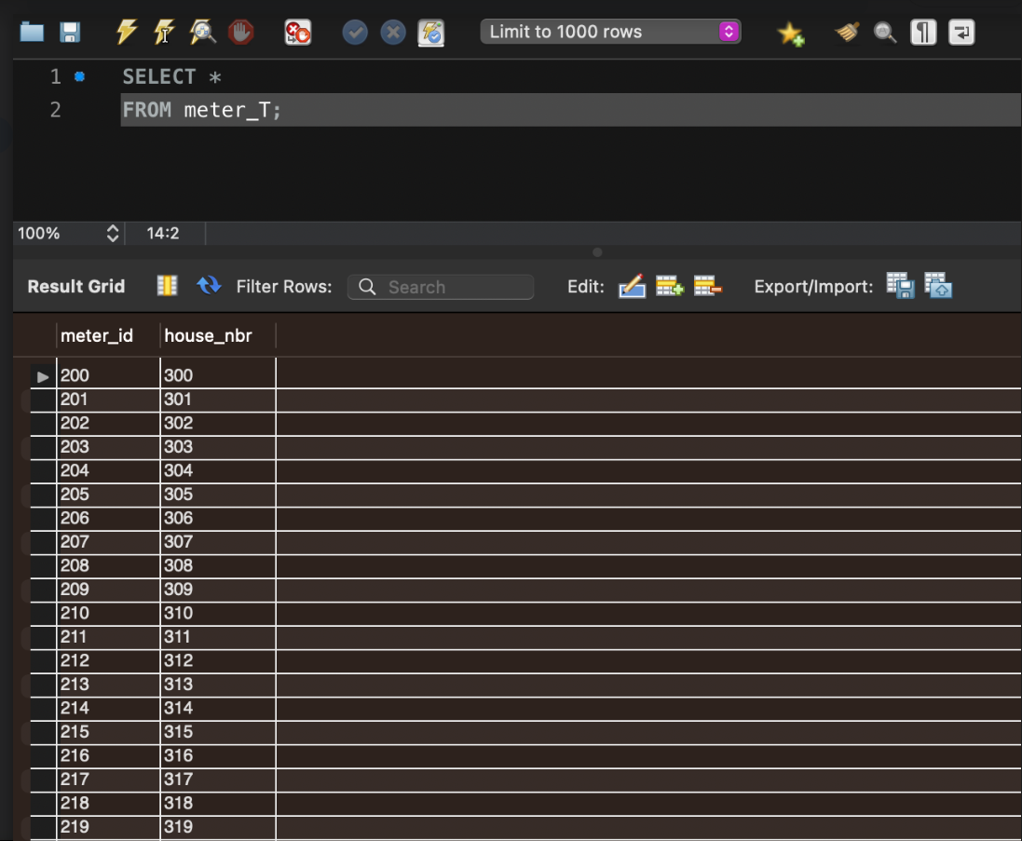

**Reading Table**

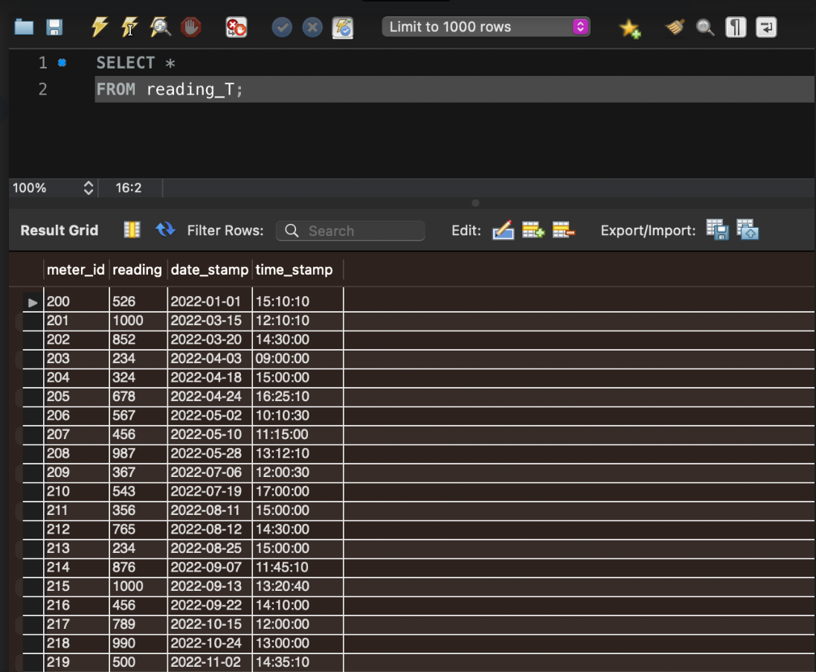

**View Table**

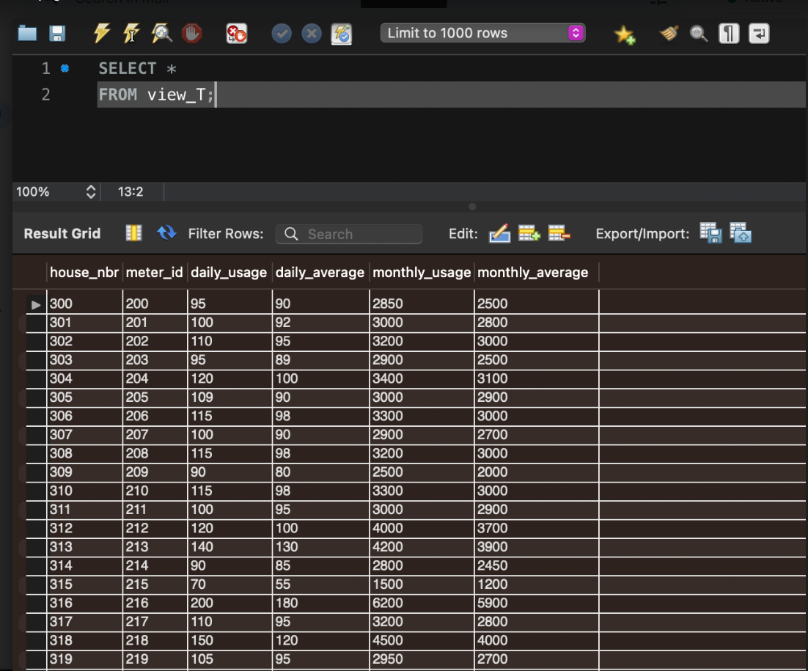

**Error Report Table**

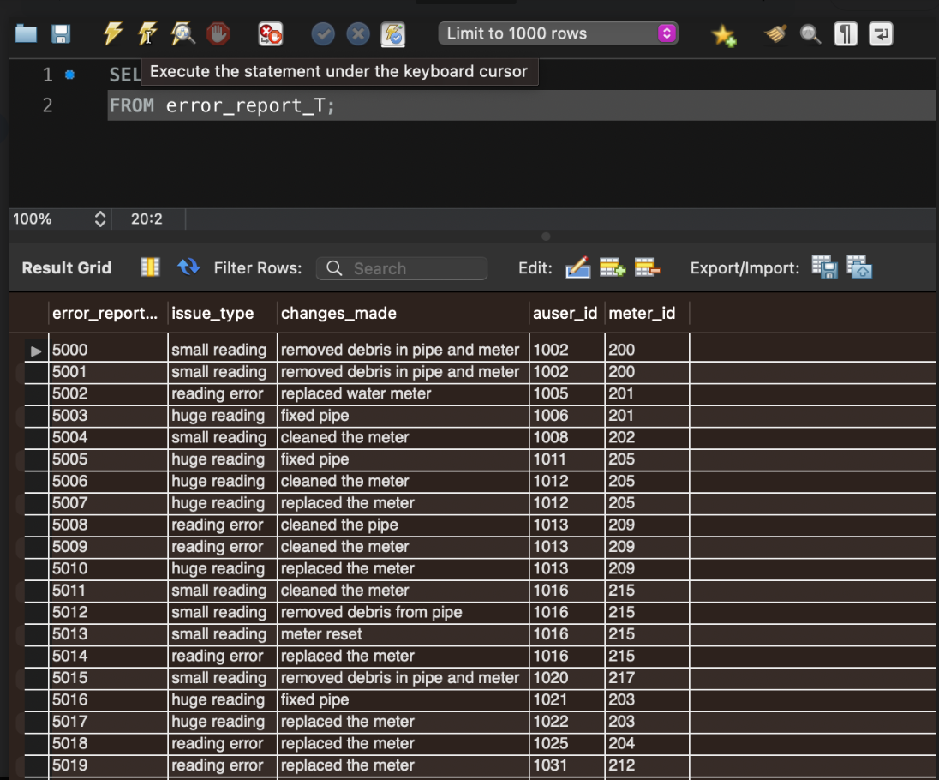

**Error Reading Table**

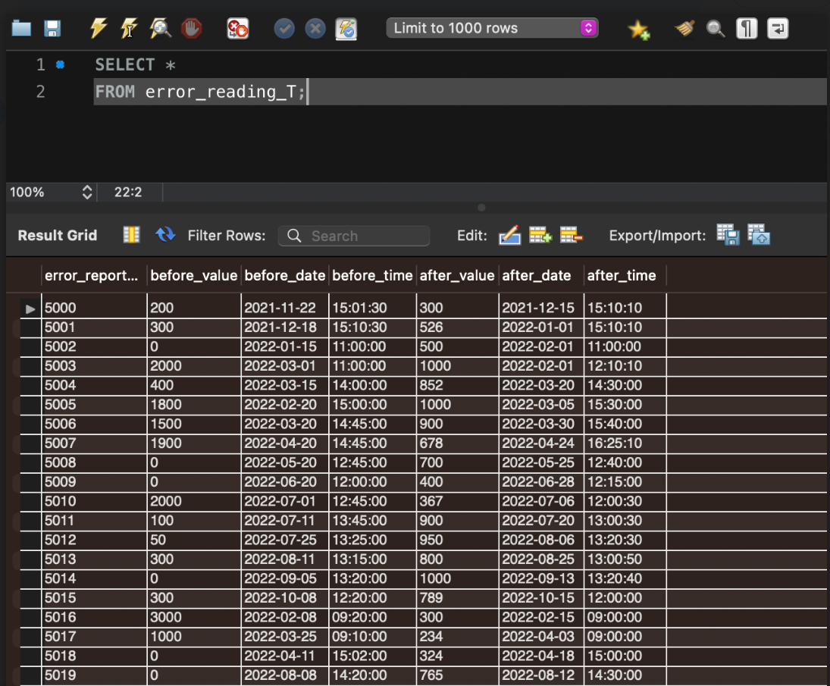

**C. Queries**

1. **Residents Living in Yellow Brick Community**

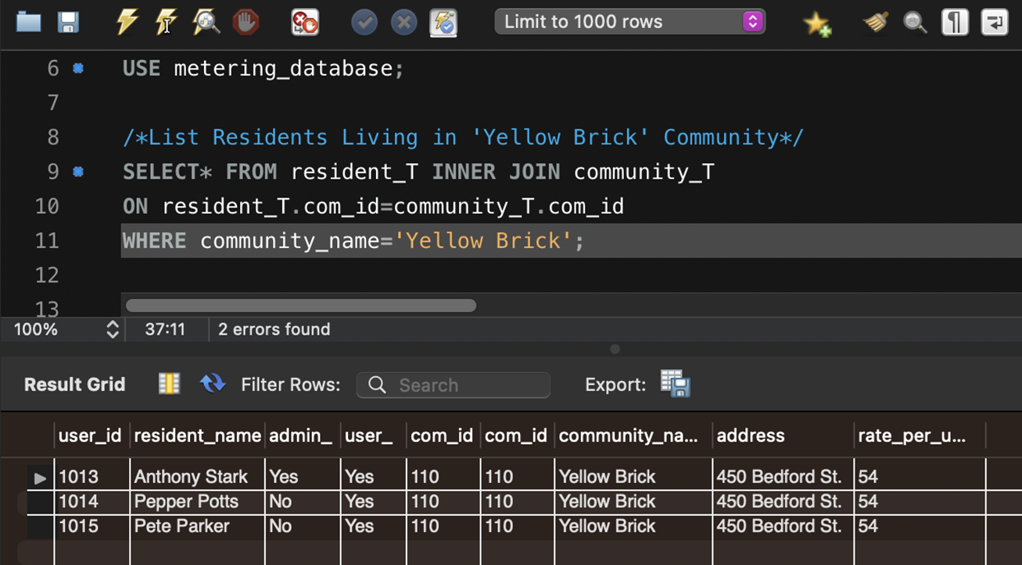

1. **Names of Residents Living in Communities w/ A Monthly Usage of Less than 15,000**

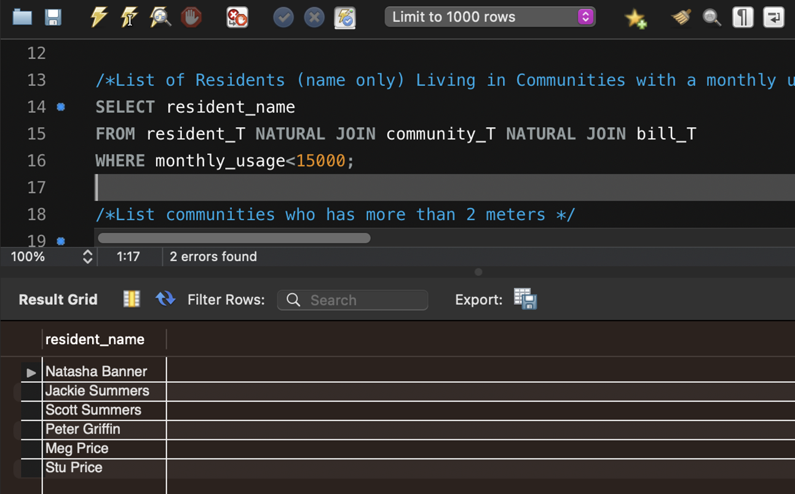

1. **List of Communities that have more than 2 meters**

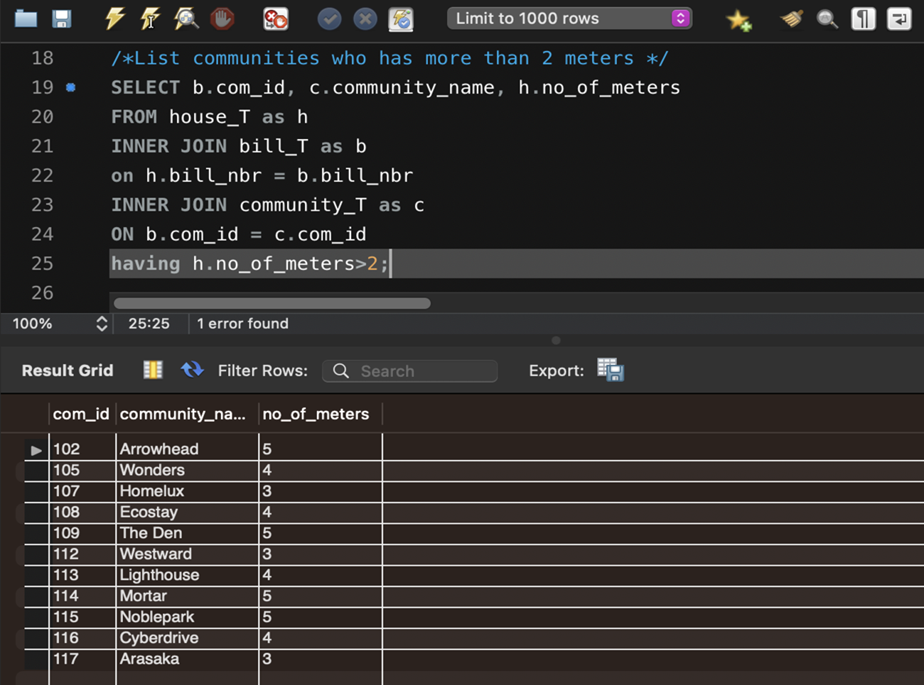

1. **List of Houses That Have Replaced Their Meters**

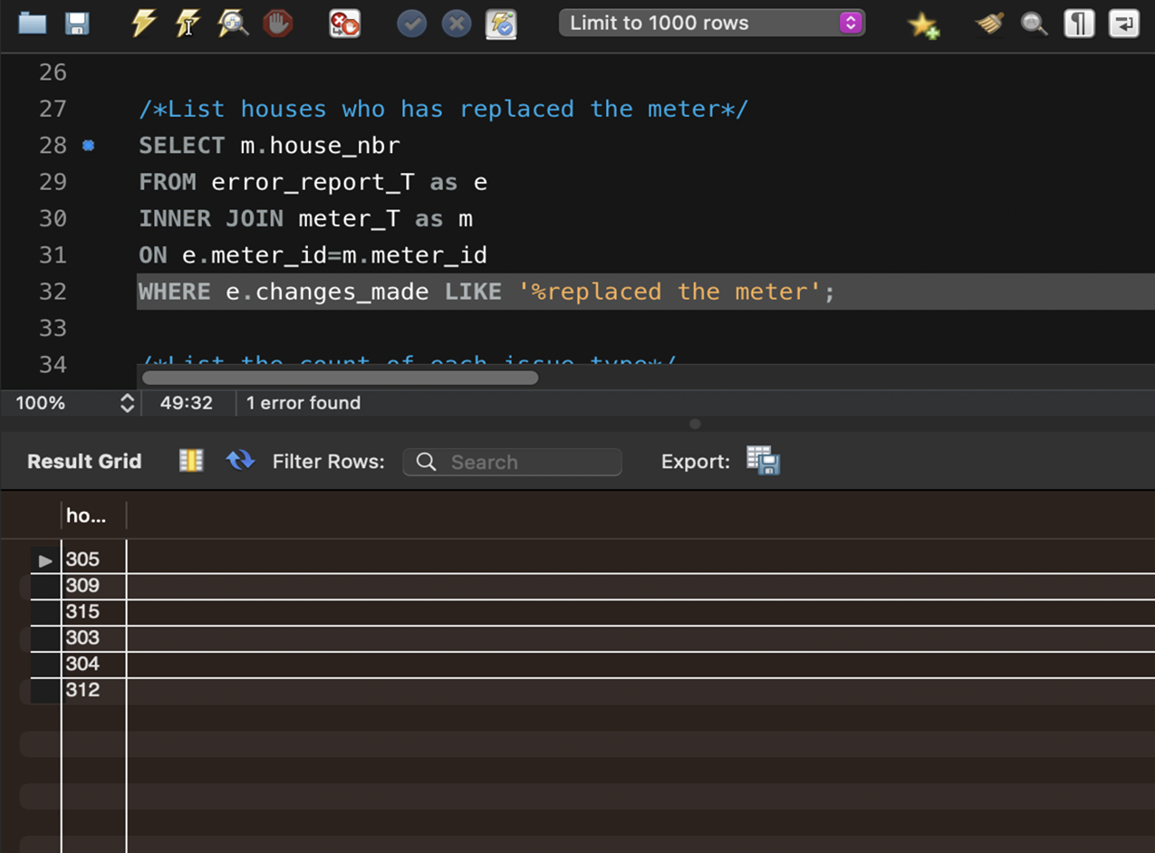

1. **List of The Count of Each Issue Type Per Meter ID**

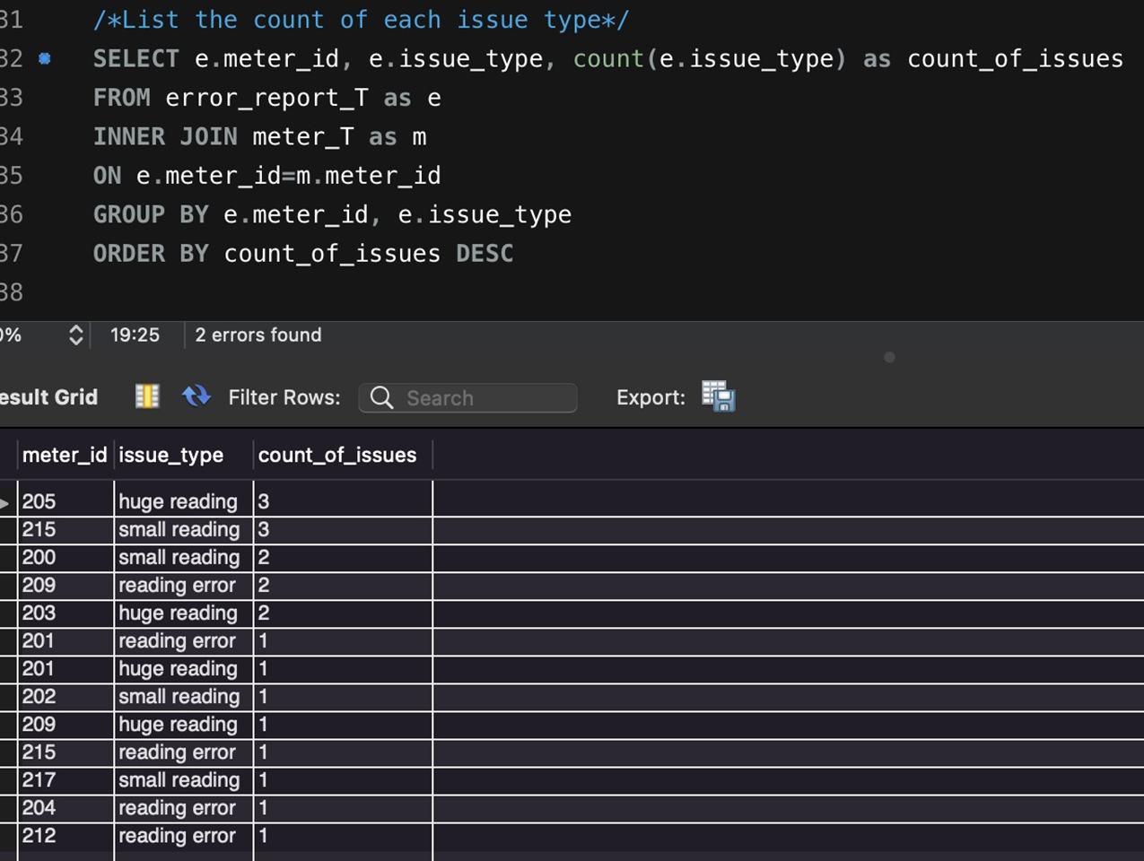

1. **List of Communities w/ Their Monthly Usages in Descending Order**

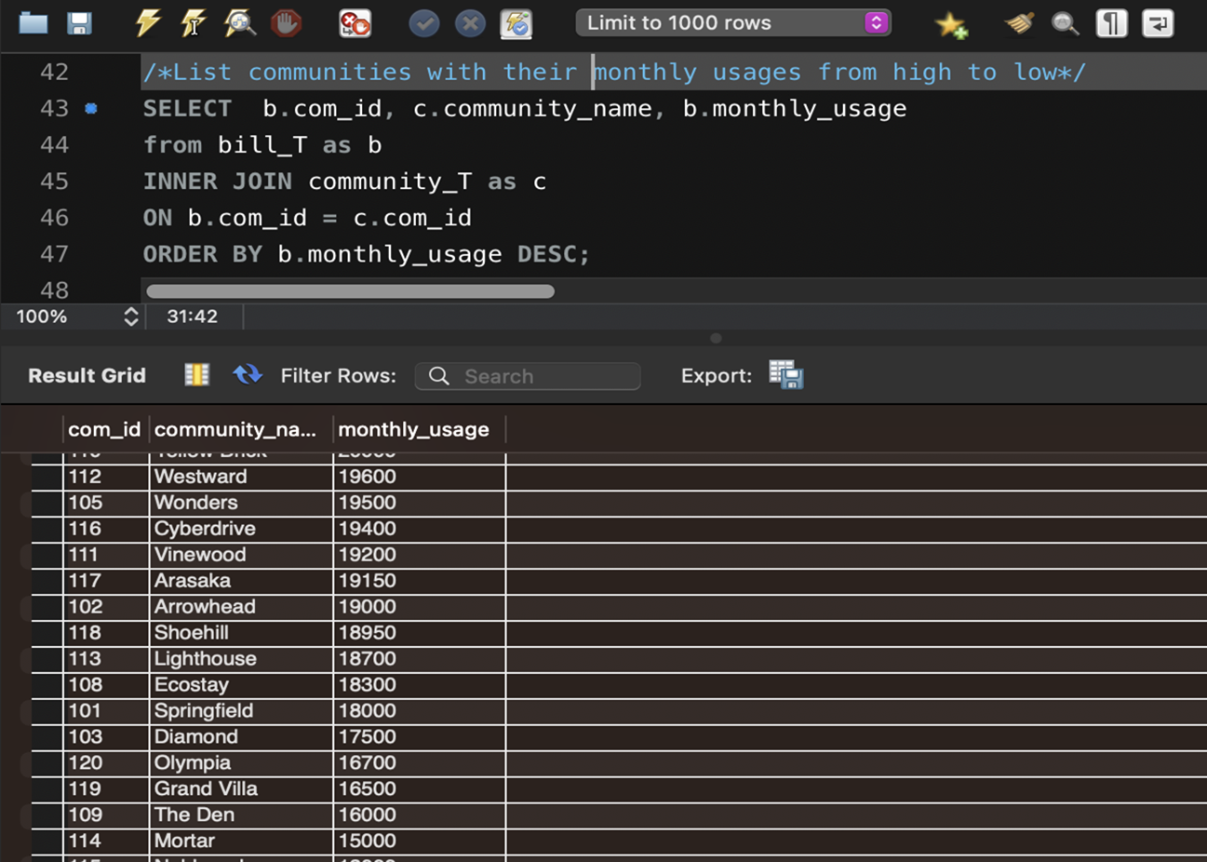

**D. Views**

1. **View for the Springfield Community who has residents**

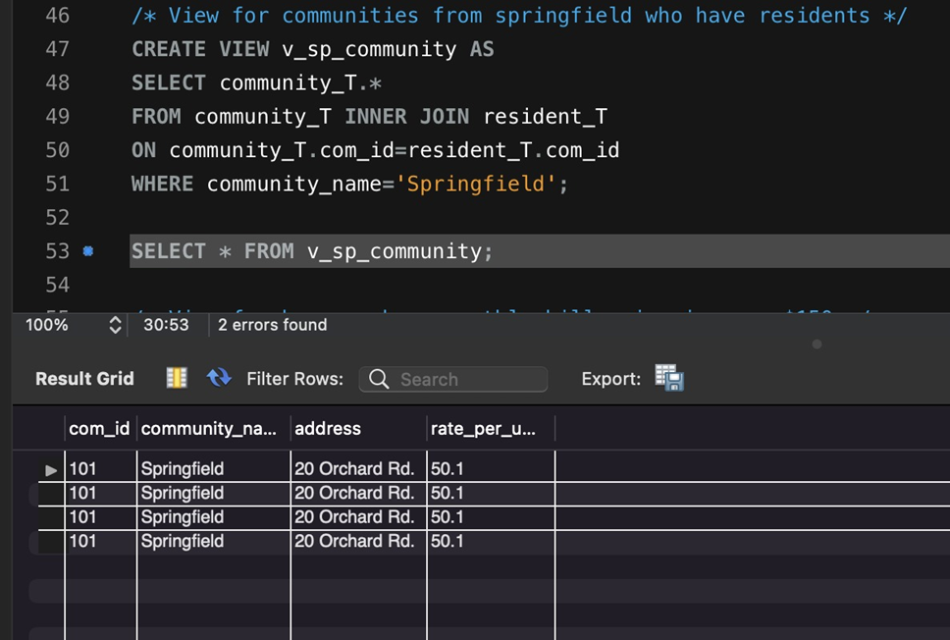

1. **View for Houses w/ A Monthly Bill of More Than $150**

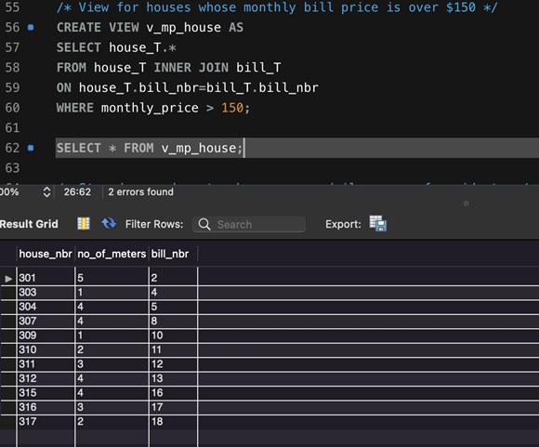

**E. Stored Procedures**

1. **Stored Procedure To Show Average Daily Usage of Residents**

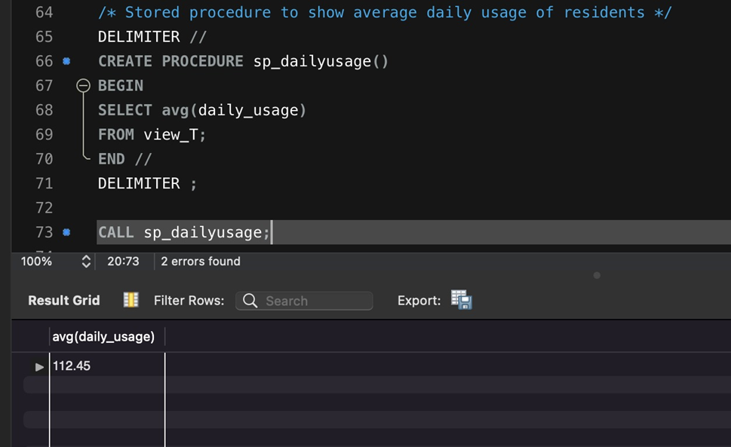

1. **Stored Procedure To List Meter Information of The Meters Having A Reading of Over 500**

